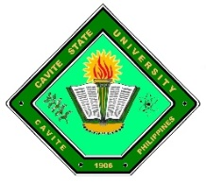
Republic of the Philippines
CAVITE STATE UNIVERSITY
Don Severino delas Alas Campus
Indang, Cavite
LLEGE OF ENGINEERING AND INFORMATION TECHNOLOGY

REQUEST FOR ADVISER AND TECHNICAL CRITIC

NAMES OF STUDENTS: | HERNZ N. RAMONES
 | STEPHEN ANDREI O. ROCILLO
 | CHARLS BENEDICK R. SOTTO
COURSE: | BACHELOR OF SCIENCE IN COMPUTER SCIENCE
AREA OF STUDY: | DATA COMMUNICATION

CONFORME:

EZRA MARIE F. RAMOS |  |  |  | MARC ELVIN D. CEREZO
Adviser |  | Date |  | Technical Critic |  | Date
RECOMMENDING APPROVAL:
ACE AMIEL E. MALICSI |  |  |  | CHARLOTTE B. CARANDANG
Unit Research Coordinator |  | Date |  | Department Chairperson |  | Date

EDWIN R. ARBOLEDA, DEng
College Research Coordinator |  | Date
APPROVED:
WILLIE C. BUCLATIN, PhD
Dean |  | Date

